**Name:**

**CO-2:**

**Batch: Roll No.:**

**Date**

**Experiment No. 7**

**Title:** Synthesis of thermosetting polymer

**Aim:** To prepare Urea formaldehyde (UF) resin

**Chemicals required:** Urea (2g), 40% aq. formaldehyde solution or formalin, conc. H2SO4

**Theory**

Thermosets: The polymers which on heating change irreversibly into hard rigid and infusible materials are called thermosetting polymers. These polymers are usually prepared by heating relatively low molecular mass, semi fluid polymers, which becomes infusible and form an insoluble hard mass on heating. The hardening on heating is due to the formation of extensive cross-linking between different polymeric chains. This lead to the formation of a three dimensional network connecting the polymer chains. Since the 3D network structure is rigid and does not soften on heating, the thermosetting polymers cannot be reprocessed. Some important examples of thermosetting polymers are Phenol-Formaldehyde resin and urea Formaldehyde resins.

Urea-formaldehyde (UF) resin, one of the most important formaldehyde resin adhesives, is a polymeric condensation product of formaldehyde with urea, and being widely used for the manufacture of wood-based composite panels, such as plywood, particleboard, and fiberboard. Urea formaldehyde resins are formed by condensation of urea and formaldehyde in acidic medium in following steps:

**Procedure :**

**Step 1: Formation of methylol urea derivative**

Initially urea and formaldehyde react to form methylol urea derivatives depending upon formaldehyde (U/F ratio).

**Step 2: Polymerization of methylol urea**

Several molecules of methylol urea derivatives condense with loss of water molecules to form a highly cross linked urea formaldehyde resin.

Procedure :

1. Take a 5 mL of 40% aqueous formaldehyde solution in a 100 mL beaker.

2. To this gradually add 2g urea powder. Stir with a glass rod to make a saturated solution.

3. Add a few drops of conc. H2SO4 and stir vigorously till a white solid mass is formed.

4. Filter the residue and wash it several times with distilled water to remove any acid.

5. Dry the residue in folds of filter paper or in an oven and weigh. Report the yield of urea formaldehyde polymer formed.

**Precautions:**

1. While adding Conc. H2SO4, it is expected to be very careful since the reaction is highly exothermic.
2. The reaction should be stirred continuously.

**Reaction:**

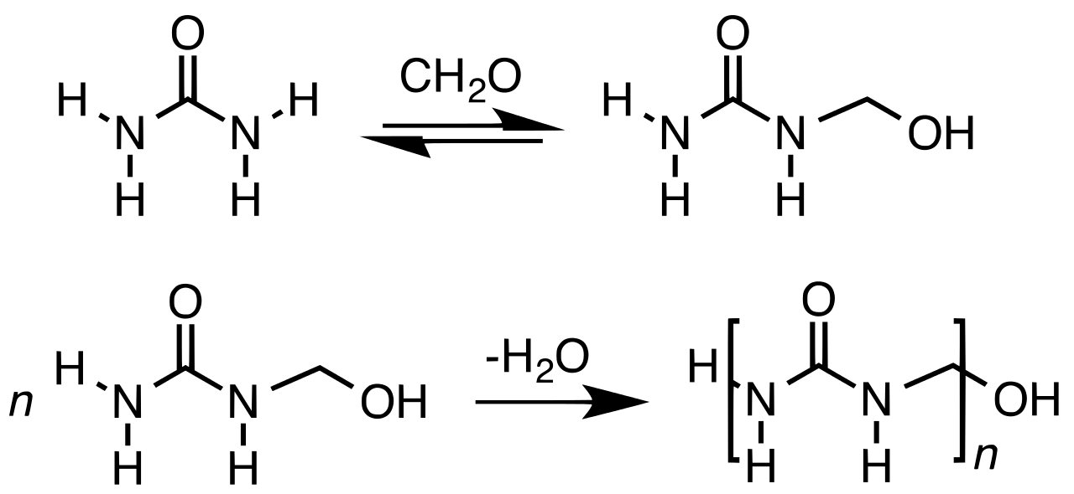

**Mechanism:**

**OBSERVATIONS**

Weight of empty filter paper = W1 g =

Weight of filter paper + polymer formed (after drying)= W2 g =

Weight of polymer formed = Wg = W2– W1 g =

**Result**

Weight of urea formaldehyde resin = W g=